NETAJI SUBHASH CHANDRA BOSE MEDICAL COLLEGE JABALPUR

Prospectus 2022-23
Bachelor of Audiology and Speech Language Pathology

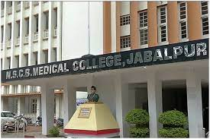

Bachelor of Audiology and Speech Language Pathology (B.ASLP)
(Affiliated to MPMSU & Recognized by RCI)

Duration of the Programme: Four years (6 semesters plus 10 month internship 7th& 8th semester ) Total number of Seats: 20

Audiology and Speech Language Pathology is an upcoming field in allied health sciences The Speech Language Pathologists and Audiologists are in demand as there are very few colleges in India that provide the educational facilities in this field. The undergraduate students of B.ASLP learn about the normal aspects and disorders of speech, language and heating. The students are trained in evaluation, diagnosis treatment and management of communication disorders. The training includes theoretical and practical aspects, with focus on clinical teaching- learning. The students get hands-on experience in dealing with clients under the supervision of qualified staff.
AUDIOLOGY is a branch of science that deals with hearing and hearing related disorders. Students of Audiology are educated regarding the anatomy and physiology of the normal and abnormal auditory system. They are trained in identification & differential diagnosis of auditory disorder. These include disorders of the middle ear, inner car, auditory nerve and the central auditory nervous system. With training they develop expertise in audiological rehabilitation, like recommendation of amplification devices including hearing aids and cochlear implants. They also learn the management of individuals with special needs such as those with tinnitus and auditory processing disorders.

SPEECH AND LANGUAGE PATHOLOGY deals with the normal and abnormal aspects of voice, speech and langunge Students of Speech Language Pathology are trained in diagnosis, differential diagnosis and management of speech and language disorders, which includes voice disorders, misarticulation, stuttering, speech and language problems associated with hearing impairment, metal retardation, cerebral palsy, cleft palate, autism, laryngectomy, stroke/paralysis, and learning disorders.

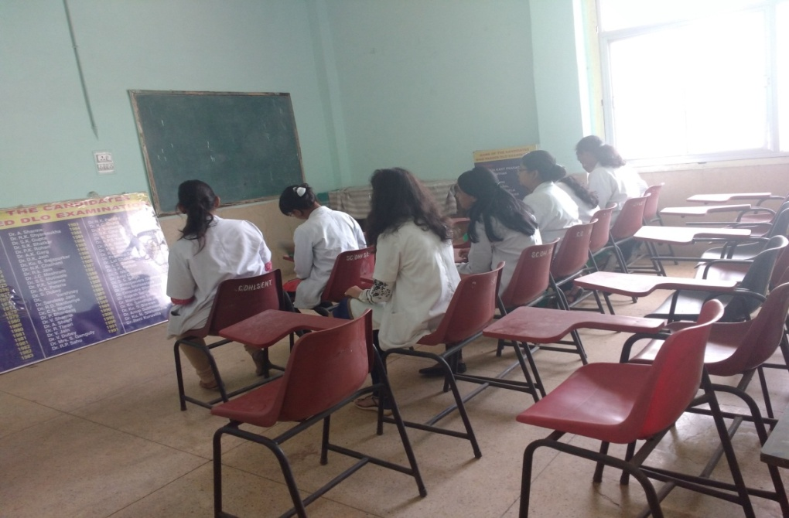
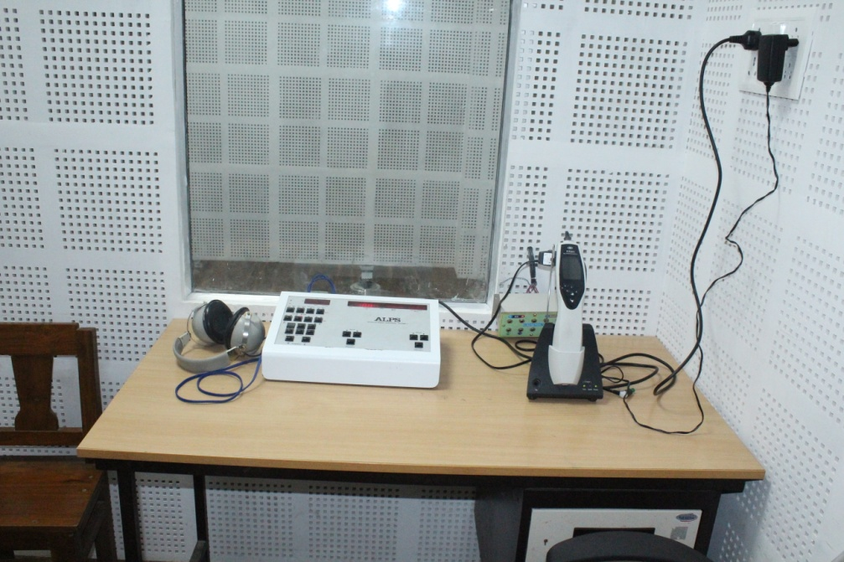

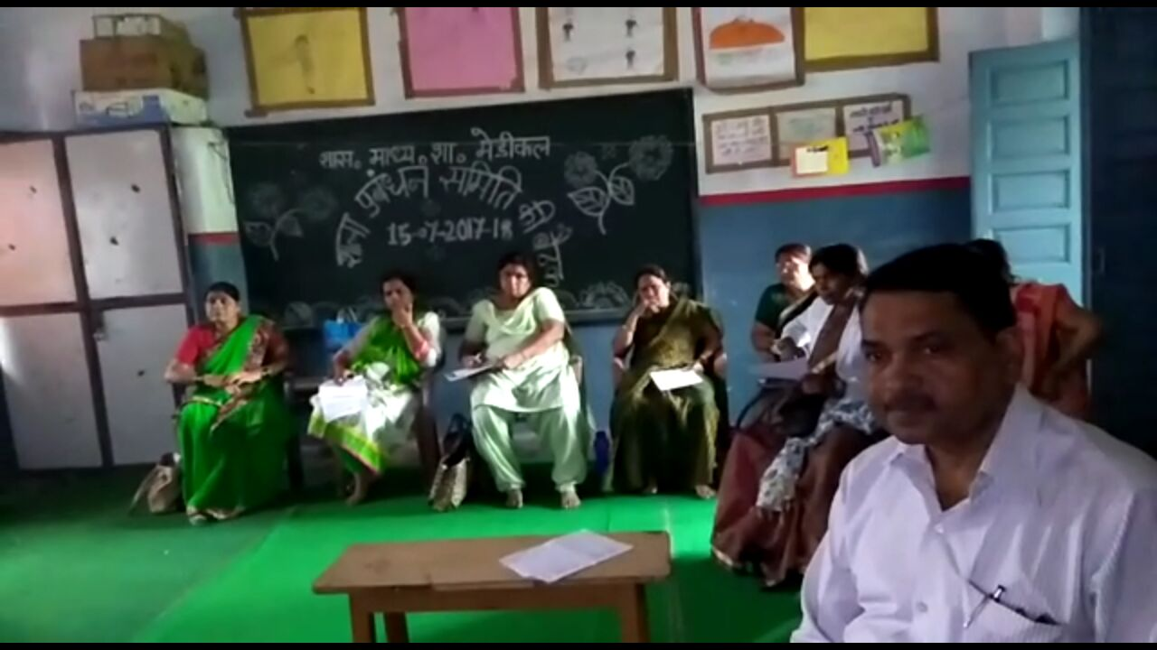

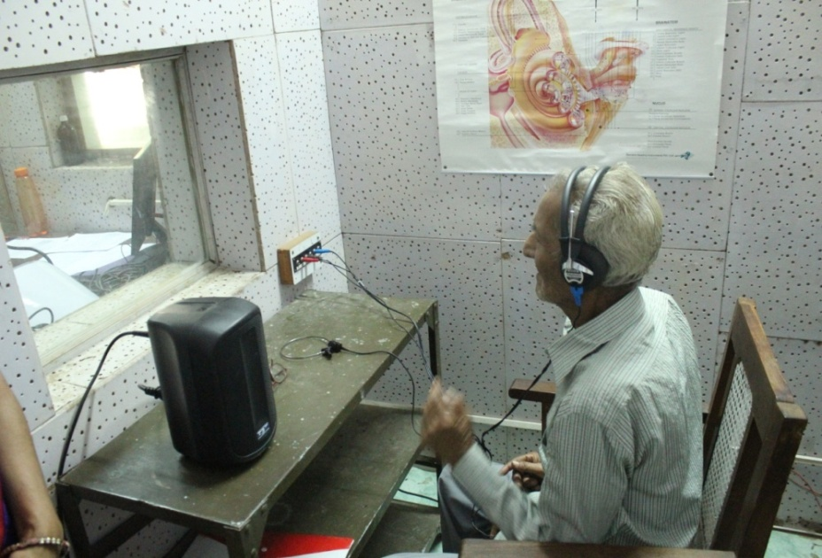

1.0 Nomenclature
As per UGC Notification of 2014, the nomenclature of the program shall be Bachelor in Audiology and Speech-language Pathology B ASLP is the short form.
2.0 Objectives of the B.ASLP program
The objectives of the B.ASLP program are to equip the students with knowledge and skills to
- Function as audiologists and speech-language pathologists in different work setting
- Understand concepts in speech, language, communication, hearing and disability
- Screen, evaluate, diagnose and assess the severity of different disorders related to speech, language, swallowing and hearing.
- Manage speech, language, swallowing and hearing disorders across life span.
- Counsel persons with disorders of communication and their family members.
- Rehabilitate persons with speech, language, swallowing and hearing disorders.
- Prevent speech, language, swallowing and hearing disorders.
- Liaise with professionals in allied fields and other stake holders.
- Implement public awareness and education program.
- Undertake advocacy measures on behalf of and for persons with speech language and hearing disorders.

ACTIVITIES OF THE COLLEGE
ACADEMIC ACTIVITIES
The college conducts a bachelors program, Bachelors in Audiology and Speech Language Pathology (B.ASLP), a four years course. The course is recognized by the Rehabilitation Council of India (RCI). The college boasts of good infrastructure and the teaching is undertaken by qualified faculty who give a good academic and practical orientation of the subject to the students. Guest lectures by experts in the field are arranged whenever required. The college has a well equipped library with books and scientific journals required for the course.
CLINICAL ACTIVITIES
The college is equipped with technology and services of qualified professionals for diagnosis and management of individuals with communication disorders. The faculty and students of the college carry out speech, language and hearing evaluations at the Department of ENT. The other clinical activities include hearing screening for newborns/ infants and bedside screening for identifying neurogenic speech & language disorder (such as aphasia, dysarthria, dysphagia apraxia) Speech, language and hearing screening camps are conducted at school and in the rural areas around Jabalpur.
CLINICAL SERVICES AVAILABLE AT THE COLLEGE
AUDIOLOGY
- Assessment and differential diagnosis of auditory disorders, which includes facilities such as pure-tone audiometry, speech audiometry, Immitance evaluation, recording of auditory brainstem responses (ABR) and Otoacoustic emissions (OAEs).
- Selection of candidates for cochlear implants and post cochlear implant rehabilitation.
- Tinnitus assessment and management.
- Assessment and management of vestibular dysfunction.
- Newborn screening programme
SPEECH LANGUAGE PATHOLOGY
Assessment and Management for individuals with
- Voice problems
- Stuttering
- Articulation problems
- Hearing impairment
- Mental retardation
- Cerebral palsy
- Cleft lip and palate
- Autism and other pervasive developmental disorders
- Neurogenic problems, such as aphasia, Learning disability, dysarthria
- Dysphagia
SCOPE OF BASLP
Plenty of opportunities are available for Audiologists and Speech Language Pathologists, both in India and overseas After completing the bachelors program, the students may pursue their education to obtain postgraduate degree or start working. Those with academic and research interests may continue their education to obtain a doctorate in the field.
Job opportunities are available for Audiologists and Speech Language Pathologists in the following set ups
- Academic Universities
- Medical Hospitals/Clinics (General hospitals, Ear Nose Throat, Paediatric or Neurology clinics)
- Special Schools for children with hearing impairment, mental retardation, cerebral palsy, autism, learning disability or others
- Normal schools
- Hearing aid/ cochlear implant industries.
- Hearing conservation program in industries
Calendar of Events for BASLP Academic Programme 2022-23 (Tentative)
Sl. No. | Details | B.A.SLP
1 | Issue of applications | 15-02-2023
2 | Last date for issue and receipt of applications | 15-03-2023
3 | Announcement of select list | 25-03-2023
4 | Counselling and admission | 30-03-2023

- 3.0 Duration of the program .
- a) The program shall be of 4 academic years including 1 year of internship and should be completed within six years from the date of admission.
- b) An academic year consists of two semesters, and each semester shall extend over a minimum period of sixteen weeks excluding examination days.
- c) There shall be examinations at the end of each semester. There shall be a vacation of minimum 1 week after the examinations at the end of odd semesters and 1 week after the examinations at the end of even semesters.
- d) Number of working days in a semester shall not be more than 100 days.

- Admission Eligibility

- 1. Admission to B.ASLP is open to candidates who have passed the 2-year Pre-University examination conducted by the Pre- University Board of the State of Madhya Pradesh or any other examination (10+2) considered as equivalent to this .
- 2. Candidates must have obtained a minimum of 50% (45% for SC/ST) in the PCM/B group or combinations in 12th class.
- 3. In case of two candidates having same percentage in 10+2, preference will be given to person having more marks in biology followed by chemistry then physics.
- 4. In case of two person having equal percentage in 12" class, then the person with biology will be preferred then person with mathematics.
- 5. If percentage in same for all the subjects of two students, then the student elder in age will be prefed.

5.0 Program Structure

Time structure of the program shall be as follows:
16 weeks / Semester 16 weeks
5 days/ week 80 Days
7 hours/ day 560hours per semester

Semester 1 Theory 6 paper ×60 hours 360 hours
Clinicals 200 hours

Semester 2 Theory 4 papers × 60 hours 240 hours
Practical 320 hours

Semester 3 Theory 4 Papers×60 hours 240 hours
Clinicals 320 hours

Semester 4 Theory 4 Papers×60 hours 240hours
Clinicals 320 hours

Semester 5 Theory 4 Papers×60 hours 240 hours
Clinicals 320 hours

Semester 6 Theory 4 Papers×60 hours 240 hours
Clinicals 320 hours
Theory 360+(240×5) 1560 hours
Clinicals 200+320+(320×4) 1800 hours
Internship 18 weeks per semester 36 weeks 5 days/week 1800 days
7 hours /day 1260 hours
Total 6 semesters 560 hours × 6 semester 3360 hours
Internship 630 hours ×2 semester 1260 hours
Total Theory 1560 hours
Total clniicals 3060 hours
Grand Total 4620 hours

6.0 Attendance
a) Minimum attendance shall be as stipulated by the respective University where the students are studying However, attendance shall not be less than 80% in theory and 90% in Clinical/ Practical's in each semester to be eligible to appear for examination at the end of each semester b) Candidates who cannot appear for the examination for want of attendance will be declared as failed and will have to repeat the particular semester to be eligible to appear for exams subsequently. c) Condonation of shortage of attendance in genuine cases shall be from the Vice-Chancellor of the respective University where the candidates are studying.

7.0 Examination Pattern

8.0 Criteria for passing
The student is required to obtain a minimum of 50% in each of the theory papers, internal assessment, practical and clinical exams for a pa Students will not be able to appear for University theory exam if they do not pass in their practical, internal assessment or clinical component Students will have to pass the clinical examination of the given semester to proceed to the next semester.

8.1 Carry-over of papers

a) Each paper should be successfully completed within 3 attempts including the first one.
b) Students can start internship after the 6nsemester exams. However, students who fail in their clinical exam of 6 semester will have to discontinue internship. The candidates are permitted to carry over the theory courses until the end of the program.

9.0 Clinical internship
All candidates shall complete a clinical internship of one academic year (10 months) after the 6th semester. The rules and regulations of clinical internship shall be as in

Guidelines for implementation of Clinical Internship of B.ASLP program with effect from the academic session 2020-21

Objectives of the clinical internship are to:
a) Facilitate transition from academic training to independent clinical responsibility
b) Provide additional inputs to attain and maintain competence in the clinical management of persons with communication disorders,

c) Initiate group and individual action focusing on prevention/early identification and intervention in individuals with speech, hearing and language impairments at the level of the individual, family and community, and
d) Provide training to understand professional responsibilities and ethical practices including
i) Rights and dignity of patients.
ii) Consultation and referral to other professionals.
iii) Conduct and professional obligations to peers/patients/families and the community at large.
Guidelines
1) Internship is mandatory
2) Duration: One academic year (10 months) split in to two semesters (VII & VIII).
3) Eligibility: Internship will start immediately after the candidate completes the academic and clinical training till the 6th semester. Students can start internship after the 6th semester exams. However, students who fail in their clinical exam of 6th semester will have to discontinue internship.
4) structure and duration of posting
a) The respective parent institutions shall decide on the institutions where their students will be posted for internship. However, students can be posted for internship only at those institutions approved by the Rehabilitation Council of India.
b) Students will do internship at their parent institute for one semester and at an institute(s) outside the parent institute for one semester Internship can be done at institutes like hospitals, special educational centers /schools , centers where clinical facilities for management of ASD, cochlear implantation, AVT etc. Are available, centres which undertake empowering of mothers, centers for CP, and centers for LD, etc. Attempts must be made to provide clinical training to students in a variety of set ups.
c) It shall be mandatory to provide additional clinical training to students in such areas as management of neurologically afflicted persons, prevention and early
intervention programs, community based rehabilitation, occupational health programs, structural abnormalities related to speech and hearing, etc.
5) Mode of supervision during internship: Supervision should generally be provided by a Speech-language Pathologist and Audiologist. However, in institute/centers where this is not feasible, supervision can be done by a specialist from an allied area like
Otolaryngology, Neurology, Mental Health, Pediatrics, among others.
6) Maintenance of records by students: Every student shall maintain records of the number of hours of clinical work in different areas and institutions. This should be certified by the head of the institution or his/her nominee where the student is undergoing internship.

Examination Pattern
The examination pattern and papers shall be as shown in the table below;
No. | Title of the paper | Practical | IA | Exam | Total
B 1.1 | Communication Science |  |  | 75 | 100
B 1.2 | Anatomy and Physiology of Speech and Hearing |  | 25 | 75 | 100
B 1.3 | Clinical Psychology | - | 25 | 75 | 100
B 1.4 | Linguistics and Phonetics | - | 25 | 75 | 100
B 1.5 | Electronics and Acoustic | - | 25 | 75 | 100
B1.6 | Research Methods and Statistics | - | 25 | 75 | 100
B 2.1 | Neurology | - | 25 | 75 | 100
B 2.2 | Otolaryngology | - | 25 | 75 | 100
B 2.3 | Speech Language Pathology | - | 25 | 75 | 100
B 2.4 | Audiology | - | 25 | 75 | 100
B 2.5 | Practical (Speech Language Pathology) | - | 25 | 75 | 100
B 2.6 | Practical (Audiology) | - | 25 | 75 | 100
B 3.1 | Voice and Its Disorder | 25 | 25 | 50 | 100
B 3.2 | Speech Sound Disorder | 25 | 25 | 50 | 100
B 3.3 | Diagnostic Audiology-Behavioral Tests | 25 | 25 | 50 | 100
B 3.4 | Amplifications Devices | 25 | 25 | 50 | 100
B 3.5 | Clinicals in Speech Language Pathology | 25 | 25 | 50 | 100
B 3.6 | Clinicals in Audiology | 25 | 25 | 50 | 100
B 4.1 | Motor Speech Disorders in Children | 25 | 25 | 50 | 100

No. | Title of the paper | Practical | IA | Exam | Total
B 4.2 | Child Language Disorder | 25 | 25 | 50 | 100
B 4.3 | Diagnostic Audiology Physiological test | 25 | 25 | 50 | 100
B 4.4 | Implantable Hearing device | 25 | 25 | 50 | 100
B 4.5 | Clinicals in Speech Language Pathology | - | 25 | 75 | 100
B 4.6 | Clinicals in Audiology | - | 25 | 75 | 100
B5.1 | Structural Anomalies & Speech Disorder | 25 | 25 | 50 | 100
B 5.2 | Fluency and its Disorder | 25 | 25 | 50 | 100
B 5.3 | Pediatric Audiology | 25 | 25 | 50 | 100
B 5.4 | Aural Rehabilitation in Children | 25 | 25 | 50 | 100
B 5.5 | Clinicals in Speech Language Pathology | - | 25 | 75 | 100
B5.6 | Clinicals in Audiology | - | 25 | 75 | 100
B6.1 | Motor Speech Disorders in adult | 25 | 25 | 50 | 100
B 6.2 | Language disorder in adult | 25 | 25 | 50 | 100
B 6.3 | Aural Rehabilitation in Adult | 25 | 25 | 50 | 100
B 6.4 | Audiology in practice | 25 | 25 | 50 | 100
B 6.5 | Clinicals in Speech Language Pathology | - | 25 | 75 | 100
B 6.6 | Clinicals in Audiology | - | 25 | 75 | 100
B 7.1 | Clinicals in speech language pathology | - | - | 100 | 100
B 7.2 | Clinicals in Audiology | - | - | 100 | 100
 |  | 400 | 900 | 2500 | 3800

OFFICE OF THE DEAN
NETAJI SUBHASH CHANDRA BOSE MEDICAL COLLEGE JABALPUR MADHYA PRADESH
JABALPUR- 482003 (M.P.) INDIA
Email- nscbmcjb@gmail.com website – www.nscbmc.ac.in
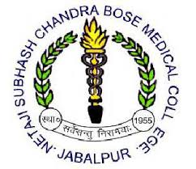
No............/2023 Jabalpur date: 13/02/2023
BASLP ADMISSION NOTIFICATION
Netaji Subhash Chandra Bose Medical College hereby invited application for admission of BASLP course for the year 2022-23. Application form and other details of the course, seat category wise distribution, course fees etc. Will be available in college website-www.nscbmc.ac.in, interested candidate can fill the form between 15/02/2023 to 15/03/2023.
SL.  NO | Programs | Duration | No. Of seats | Mode of selection | Eligibility Criteria | Age Limits
1. | Bachelor of Audiology and Speech Language Pathology  (B.ASLP) | 4 Years | 20 | The eligible candidate will be called for verification of document based on it the selection will be carried out. As per M.P. government admission rules. | 1. Minimum 60% ( 55 % for SC/ST) marks to be secured in 12th class.  2. Must studied at least 3 subjects in 12th class physics, Chemistry, Biology and Mathematics. | 17 years- 25 years by 1st July 2023 (upper age limits).

- RCI Approved Course
- All Disputes will be under Jabalpur Jurisdiction.

DEAN
NSCB Medical college Jabalpur

